**The Influence of Various Accommodation Attributes on the Price of Airbnb Listings Compared to the Perceived Price-Quality Ratio by Customers: A Multiple Linear Regression Analysis**



Course: Data Preparation and Workflow Management ([328059-M-3](https://tilburguniversity.instructure.com/courses/9204))

Team number: 3

Team members: Lesley Haerkens (***), Mandana Khabbazi (***), Daniëlle van Bruggen (***), Anouk Bor (***), Mila Gargiulo (2019215)

Submission date: 18/10/2021

Word count: ***

1 Introduction

Airbnb is the perfect example of a platform that has arised as a result of the latest phenomenon, the sharing economy, being the largest accommodation firm in the marketplace with a remarkable volume of XXX listings and a record-breaking growth in the number of guests. The platform allows its users to share their underutilized properties through its website with relatively lower transaction costs and usually at a lower rate compared to those of traditional businesses. Therefore, renting a place on the Airbnb site – both as a consumer and a supplier - is tied to many economic and financial benefits that have allowed the concept to grow tremendously in popularity over the last couple of years. However, it is not only its cost-saving benefits that participants of the sharing economy disclosed attracted them to using Airbnb, but also for its social benefits. The value of Airbnb listings is perceived differently from that of traditional hotels for instance, as consumers seem to attach more value to the whole experience of their stay and especially the friendliness, sociability, and trustworthiness of their host. Airbnb enjoys a competitive advantage over the traditional businesses as its supply dynamics are much more flexible than those of traditional accommodations, which forms a substantial threat. Therefore, the platform is recognized as a disruptor for the lodging industry. Researchers have found that a one percent increase in the number of Airbnb listings decreased hotel room revenue by 0.5% in Texas (Zervas, Byers, & Proserpio, 2017). On the other hand, the sharing economy seems to primarily provide positive economic benefits for the local communities and the tourism industry, as it generates new jobs and sources of income (Fang, Ye & Law 2015).

It now has become vital for the hotel industry to understand what drives consumers to book Airbnb accommodations in order to develop strategies to compete with this corporation. The physical (i.e., space, location, amenities, etc.) and non-physical (i.e., sociability, trustworthiness, friendliness, etc.) attributes, which are reflected on the price of the Airbnb accommodations, may play a crucial role on Airbnb guests’ decision making. Thus, the price of Airbnb properties is determined based on the value consumers place on the attributes of Airbnb accommodations. Therefore, examining the price determinants of Airbnb properties may play a crucial role in understanding the factors that drive the growth of the sharing economy based on accommodation services.

There have only been a few studies on investigating the pricing determinants of sharing economy-based services. These examined the effects of reviews, ratings, and host photos on the prices of Airbnb accommodations. As an example, hosts awarded a superhost badge – meaning they have a good standing and excellent service standards – post their properties at higher prices, especially when they receive more reviews are higher ratings (Liang, Schuckert, Law & Chen 2017). Moreover, guests seem to determine the trustworthiness of hosts from their photos and are willing to book more expensive Airbnb properties if the hosts seem to be trustworthy. However, online reviews and ratings did not appear to influence the listing price (Ert, Fleisher & Magen, 2015). This may be the case because Airbnb hosts have a rating of 4.5 out of 5, which is very extreme compared to hotel firms’ ratings (Zervas, Proserpio & Byers 2015). In general, factors related to the site and property characteristics, amenities, services, rental rules, and customer reviews significantly affect the prices of sharing economy-based accommodations. In particular, Airbnb listings that offer amenities such as real beds, Wi-Fi, and free parking had higher prices compared to who did not.

According to Airbnb themselves, they found that guests often filter their search results to find the top 10 amenities. Therefore, it is vital for hosts to include these amenities in their listings to increase bookings of their listings. The top 10 amenities as perceived by guests includes a pet-friendly space, wifi, free parking, pool, jacuzzi, kitchen, air conditioning, heating, washer, TV. Hosts should think about what amenities might appeal to different types of travellers, e.g. distinguish between families with kids (cribs, high chairs, baby gates, changing tables, baby monitors, outlet covers, kids’ cups and plates), pet parents, and remote workers (workspace, coffee maker) (Airbnb, 2020).

**One more small paragraph on what we are going to study and why it is relevant**

2 Method

The data analysed was obtained by InsideAirbnb, which is an activist project with the objective to provide data that quantifies the impact of short-term rentals on housing and residential communities, and provides a platform to support advocacy for policies to protect our cities from the impacts of short-term rentals (InsideAirbnb, 2021). Airbnb listings with no reviews were removed from our analysis to provide more accurate estimates, as Airbnb listings with at least one review will be closer to the market equilibrium price. Similarly, we got rid of the listings where the listing price was zero, because that aims at a missing value or an inaccurate measurement. Therefore, these listings are removed from the analysis, as they can lead to incorrect conclusions.

For our analysis we classified the attributes of Airbnb accommodations – the non-metric independent variables of this study - into 7 categories of amenities, for which we would like to measure its effect on the price.

The first category is space attributes, which include whether the listing is a private room, shared room, hotel room or entire home and whether the accommodation has a balcony, backyard, waterfront, lake access, beach front, private entry and a dedicated workspace. Studies have shown that people in general are willing to pay more for space and privacy, even though the sharing economy is a social platform wherein people are motivated by social interaction (Dogru & Pekin, 2017). This indicates that there is a high chance that this matter has an influence on the price-quality ratio which makes it interesting to incorporate in the analysis.

The second category that this research will look at is attributes of the listing quality, such as the number of reviews, the mean review rating and the number of beds and bedrooms.

The third category is common listing attributes. These are attributes that are often present in accommodations and can be describes as household items in a similar way as guests have in their own home (Chattopadhyay & Mitra, 2019), like a kitchen, oven, stove, bed linens, washer, dishwasher etcetera.

The fourth category contains ‘extra’ listing attributes, like a hot tub, fireplace, air conditioning, sauna, pool, hot tub, gym, or BBQ.

The fifth category contains the host quality attributes which include the number of listings by the owner, superhost status, their usual response time and rate, and whether they are licensed and greet their guests. As discussed before, Airbnb is a sharing economy, in which people are motivated by social interaction. This is why these host quality attributes is expected to have an influence on the price quality ratio so it is part of the measure.

The sixth category contains some convenience attributes potential consumers may be looking for – with a focus on specific target audiences – such as young families with children, the disabled or animal-lovers. Namely, they attach value to the presence of – among other things – a crib, high chair, elevator, baby monitor, and whether pets are allowed and it is a single-level accommodation.

Finally, the seventh category contains safety attributes. These attributes include a fire extinguisher, security cameras, first aid kit, and carbon monoxide alarm; to make you prepared for anything. Research has shown that customers would recommend a place more often when the hosts receives a ‘safety card’, meaning that for example a smoke alarm and locks are provided in the room (Zhang, et al., 2020). The presence of these safety attributes can thus lead to a higher rating which means it can influence the price/quality ratio. This makes it relevant to add in the analysis.

The final sample of our study consists of 13,773 Airbnb properties that are available or booked on the moment we performed the analysis (10/2021). **Tables 1 until 8** present the summary statistics of the dependent and independent variables used in this study, along with minimum and maximum values of these variables where applicable. The tables have been divided according to the 7 attribute categories, plus an extra table for the general information and dependent variable statistics. This has been done for easing the interpretation process of the following paragraphs.

**Table 1:** Summary Statistics – General Information and Dependent Variable

**Table 2**: Summary Statistics – Space Attributes

**Table 3**: Summary Statistics – Listing Quality

**Table 4**: Summary Statistics – Common Listing Attributes

**Table 5**: Summary Statistics – Extra Listing Attributes

**Table 6**: Summary Statistics – Host Quality Attributes

**Table 7:** Summary Statistics - Convenience Attributes

**Table 8**: Summary Statistics - Safety Attributes

The dependent variable, the price (nightly room rate), that can be found in **Table 1**, averages $149.90 in the city of Amsterdam and ranges anywhere between $4.00 and $999.00. Compared to the official global average of Airbnb listings, which was $110 per night in 2020, Amsterdam’s listing prices clearly lie above average. Furthermore, within **Table 1** one can observe that the mean number of listings per host equals to 1.951.

In terms of the space attribute category, **Table** 2, the following can be deduced. According to our summary statistics, 77,89% and 21,22% are entire homes and private rooms respectively, whereas only 0.27% and 0.62% are shared rooms and hotel rooms respectively. Moreover, 29.79% of the accommodations features a balcony, 2.16% has lake access, 7.70% has a waterfront, and 12.86% includes a backyard.

The listing quality category, **Table 3**, provides important information. Overall, the mean ratings of the listings varied widely between 1 and 5, listings had 28.78 reviews on average, and hosts receive a mean overall rating of 4.761 (which is a remarkably high average). Next to an overall rating, reviews have been categorized in multiple categories, such as cleanliness, location, checkin, and value. The value reviews become important in the second part of our analysis, as it represents the new dependent variable. The variable presents reviews of consumers within the topic of value-for-money. This is a crucial statistic for our research, as we want to compare whether the attributes that scored high in the ‘price’-analysis (the first analysis) match those that score high based on value-for-money reviews. The average value rating in our study amounts to 4.602, which again can be considered of particular high value.

In general, a WiFi is the amenity most commonly offered in an Airbnb property. 98.18% of the hosts offered access to WiFi. Interestingly, according to Alhamad and Singh (2021), (free) WiFi is a less critical feature to influence consumer ratings, compared to a few years ago. The reason for this is that consumers consider a WiFi option to be a standard possibility, as almost all hospitality accommodations provide for it. Furthermore, consumers nowadays have alternatives to WiFi, such as mobile internet options. Next, the common listing attributes kitchen and laundry opportunities follow closely, where 88.17% and 80.05% of the hosts offered access to a kitchen and the use of washer in Amsterdam respectively. Moreover, 77.68% features a TV and 39.69% includes bedlinens. This information all can be deduced from **Table 4**.

**Table 5**, on the other hand, displays statistics on extra listing attributes. The percentage of Airbnb hosts who offered free parking and luggage drop-off were 9.63% and 18,50% respectively. Moreover, 96.92% offered heating, 5,78% offered a breakfast option, and only 0.58% offered access to a pool.

As can be deduced from **Table 6**, 14.24% of the listings was listed by a host with a superhost status. The presence of a superhost badge often reflects a significant price mark-up (Liang, Schuckert, Law & Chen 2017), as discussed before. Moreover, 28.07% of the hosts incorporated a way to greet visitors. Katsumi et. al. (2017) suggest these greetings are important, especially in terms of ethnic and gender differences. It may have a significant impact on successful social interaction.

As for convenience attributes, 8.35% hosts provide access to a crib, 2.18% features baby safety gates, and *none* of the hosts allows to bring along pets.

Lastly, **Table 8,** displays statistics for safety attributes. We can deduce that 41.96% features a fire extinguisher, 2.94% provide security cameras, and 43.97% for a carbon monoxide alarm.

3 Analysis

We examined the price determinants of Airbnb properties utilizing the ordinary least squares (OLS) regression technique. In particular, we analysed the effects of space, listing quality, common listing, extra listing, host quality, convenience and safety attributes on the nightly published rate of Airbnb listings in Amsterdam.

Moreover, we examined how consumers’ perception of the price/quality ratio of a listing is established. Therefore, we measure the effect of several variables on the ‘rev_value’ rating of consumers to see, e.g., which amenities (of which categories) contribute the most to a higher rev_value rating by consumers. This could help Airbnb hosts in deciding which amenities they should offer if they are for instance limited on a budget, but still try to accommodate to its guests’ needs as close as possible.

4 Results

The results of the analysis of the attribute factors on the nightly published rate of Airbnb listings is presented by Table 2:

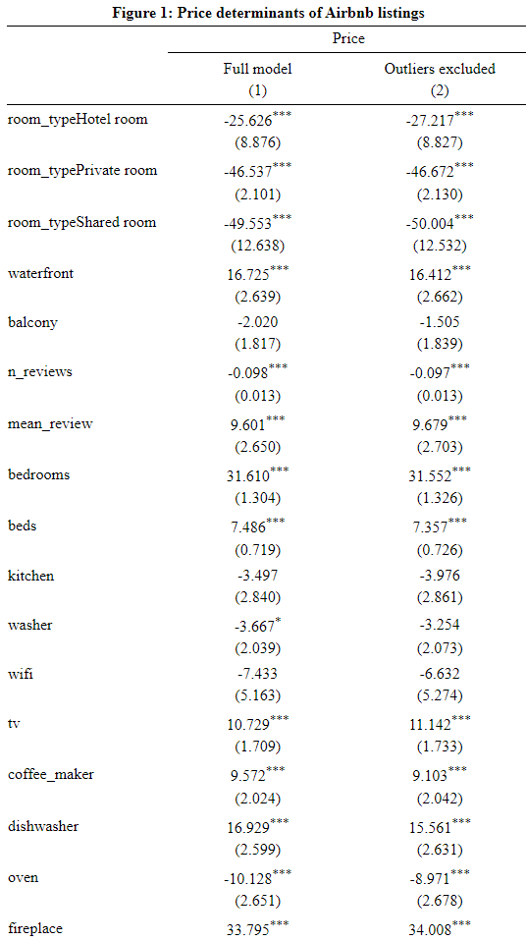 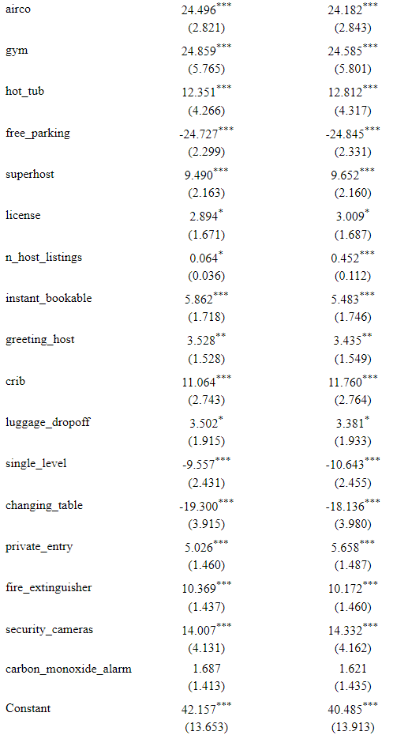

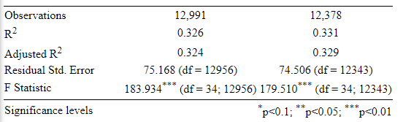

**Table 2: Price Determinants of Airbnb accommodations**

From these results, for Amsterdam, we can conclude that many of the variables examined turned out to have a significant effect on the price. To discuss these effects per category:

* Space attributes

For room_type, the baseline taken was an entire home, which typically pertains to the largest listings. Therefore, hotel room, private room, and shared room all have a negative effect on the price (which are significant at p<0.01). For waterfront we observe a significant positive effect on the price (at p<0.01). For balcony the negative effect is not significant, so we can not draw any conclusions from these estimates.

* Listing quality attributes

N_reviews has a slight negative effect on price, but which is significant (at p<0.01), which is remarkable as we would expect this effect to be positive or at least neutral. Mean_review has a positive significant effect on price (at p<0.01). This is the same for bedrooms and beds.

* Common listing attributes

Kitchen does not have a significant effect on price, just like washer and wifi. Thus we can not conclude anything from these estimates. The presence of a TV does have a significant positive effect on price (at p<0.01), just like coffee_maker, dishwasher, oven. Therefore the total significant effect of this category on the price is = 26.835 (at p<0.01).

* Extra attributes listing

For this attribute category, we see that all variables have a significant effect on the price. The estimates for fireplace, airco, gym and hot_tub are positive, while free_parking has a negative effect. Therefore the total significant effect of this category on the price is = 70.742 (at p<0.01).

* Host quality attributes

Superhost has a positive significant effect on price (at p<0.01), just like n_host_listings, and instant_bookable. License and greeting_host both too are significantly positive but at significance levels of p<0.1 and p<0.05 respectively.

* Convenience attributes

Crib has a significantly positive effect on price (at p<0.01). Luggage_dropoff has a positive effect at p<0.1. Single_level has a negative effect on price at p<0.01, just like changing_table. Therefore the total significant effect of this category on the price is = -13.638 (at p<0.1).

* Safety attributes

All variables of this category, except for carbon_monoxide_alarm have a positive significant effect (at p<0.01 on the price. The variable carbon_monoxide_alarm is not significant. Therefore the total significant effect of this category on the price is = 29.402 (at p<0.01).

*Also add some more plots made in R studio*

In sum, we may thus conclude that the category safety attributes (for the variables that we analysed) has a more positive effect on price than the category convenience attributes. While the category extra attributes listing has the highest significant positive effect on the price (which would be in line with out expectations).

5 Discussion

Although Airbnb guests might place more value on the sociability, trustworthiness and friendless of their Airbnb hosts and the experience, Airbnb guests are, to some extent economically motivated. They might be specifically comparing Airbnb and traditional hotels for cost-saving purposes. The results of research by Chen & Xie (2017) showed that Airbnb guests placed more value on space, cleanliness, free breakfast, location, and unique experiences. Based on this information, hotel firms might focus on these factors to attract guests from Airbnb’s consumer base. Airbnb guests would pay more for space and privacy, despite the conception that the sharing economy is a social platform where participants are motivated by potential social interactions. They pay less for properties that allow access to the kitchen, suggesting that these are regular apartments and houses and that Airbnb guests are not likely to pay extreme prices for staying in such properties. Guests pay more for more photos of the Airbnb properties, but they pay lower rates for Airbnb properties that seem to have commercial purposes.

6 Conclusion

In conclusion, guests pay higher rates for ….

7. References

Alhamad, I. A., & Singh, H. P. (2021). Predicting Key Factors Impacting Online Hotel Ratings Using Data Mining Approach. *International Transaction Journal of Engineering, Management, Applied Sciences, and Technology, 12*(2). [DOI: 10.14456/ITJEMAST.2021.35](http://doi.org/10.14456/ITJEMAST.2021.35)

Chattopadhyay, M., & Mitra, S. K. (2019). Do airbnb host listing attributes influence room pricing homogenously?. *International Journal of Hospitality Management*, *81*, 54-64. DOI: 10.1016/j.ijhm.2019.03.008

Chen, Y., & Xie, K. (2017). Consumer valuation of Airbnb listings: a hedonic pricing approach. *International Journal of Contemporary Hospitality Management*, *29*(9), 2405–2424. Retrieved from <https://doi.org/10.1108/ijchm-10-2016-0606>

Dogru, T., & Pekin, O. (2017). What do guests value most in Airbnb accommodations? An application of the hedonic pricing approach. *Boston Hospitality Review, 5*(2). Retrieved from https://www.researchgate.net/publication/317598245

Ert, E., Fleischer, A. & Magen, N. (2016). Trust and Reputation in the Sharing Economy: The Role of Personal Photos on Airbnb, *Tourism Management, 55*, 62-73. Retrieved from http://dx.doi.org/10.1016/j.tourman.2016.01.013

Fang, B., Ye, Q., & Law, R. (2016). Effect of sharing economy on tourism industry employment. *Annals of Tourism Research, Elsevier, 57*(C), 264-267. DOI: 10.1016/j.annals.2015.11.018

Katsumi, Y., et. al. (2017). When Nonverbal Greetings “Make It or Break It”: The Role of Ethnicity and Gender in the Effect of Handshake on Social Appraisals. *Journal of Nonverbal Behavior, 41*, 345-365. Retrieved from <https://doi.org/10.1007/s10919-017-0257-0>

Liang, S., Schuckert, M., Law, R., & Chen, C. (2017). Be a “Superhost”: The importance of badge systems for peer-to-peer rental accommodations. *Tourism Management, 60*, 454-465. Retrieved from <http://dx.doi.org/10.1016/j.tourman.2017.01.007>

Zhang, G., Cui, R., Cheng, M., Zhang, Q., & Li, Z. (2020). A comparison of key attributes between peer-to-peer accommodations and hotels using online reviews. *Current Issues in Tourism*, *23*(5), 530-537. Retrieved from <https://doi.org/10.1080/13683500.2019.1575339>

Zervas, G., Proserpio, D., & Byers, J. W. (2017). The Rise of the Sharing Economy: Estimating the Impact of Airbnb on the Hotel Industry. *Journal of Marketing Research, 54*(5), 687-705. Retrieved from <https://doi.org/10.1509/jmr.15.0204>

Airbnb (2020). The best amentities to offer right now: From wifi to a pet-driendly space, here’s what guests care about most. Retrieved from <https://www.airbnb.com/resources/hosting-> homes/a/the-best-amenities-to-offer-right-now-203